**In-Class Exercise – Due: February 9, 2019 – before 10:00pm**

**Objective:** Output **with** Variables

|  |
| --- |
| **Important instructions:**   * *All programs must include comments at the top of your program: your name,* the class name (CSIT 575)*, program name and* ***the program description (purpose of the program).*** * *Copy and paste your* ***program code*** *and* ***output*** *in Part B of each program. Note: Use snipping tool to snip the output.* * *Once it is done, save and submit this word file via Canvas.* |

1. **MilesPerGallon.cpp** program

A car holds 20 gallons of gasoline and can travel 312 miles before refueling. Write a program that computes the number of miles per gallon the car gets. Display the result on the screen.

**Sample Output:**

The car gets 15.6 miles per gallon.

**Part A: Pseudocode**

Input or given data: 20 Gallons, 312 Miles

Processing: 312 / 20

Output: Display “This car gets 15.6 miles per gallon”

**Part B: Copy and paste your program (source) code and the outputs after this line.**

+++++++++++++++++++++++++++++++++++++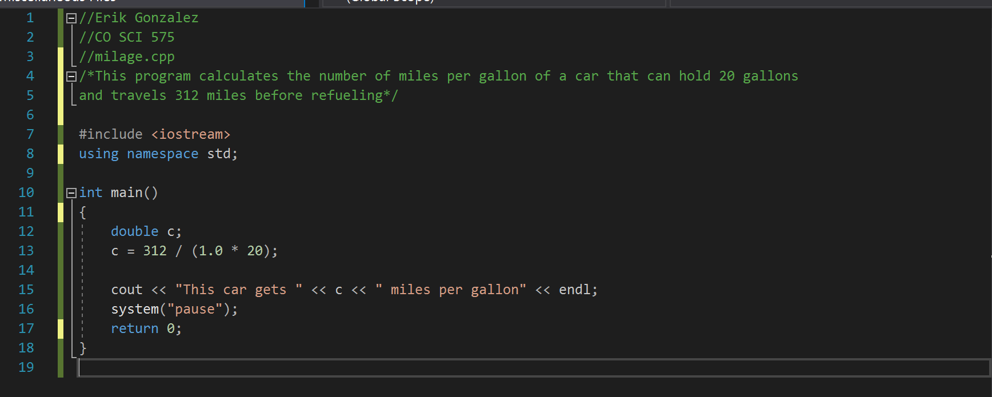+++++++++++++++++++++++++++++++

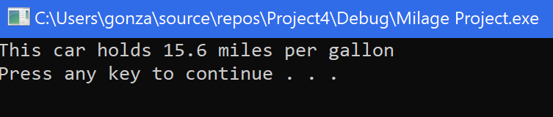

1. **Rectangle.cpp program**

Write a C++ program that calculates and displays the area and perimeter of a rectangle.

Given:

width = 7; length = 12

Example of Output:

**A rectangle has a length 12 and a width 7.**

**The area of the rectangle is 84**

**The perimeter of the rectangle is 38**

**Part A: Pseudocode**

**Input or given data:**

**Length of 12, and Width of 7.**

**Processing: Area = Length(12) * Width (7)**

**Perimeter = 2 * (Length(12) + Width(7))**

**Output:**

**Display “A rectangle has a length of 12 and a width**

**7.”**

**Display “The area of the rectangle is 84”**

**Display “The perimeter of the rectangle is 38”**

**Part B: Copy and paste your program (source) code and the outputs after this line.**

++++++++++++++++++++++++++++++++++++++++++++++++++++++++++++++++++++

